Dimensionality Reduction & Feature Selection

Geoffrey Chege

2022-06-10

# 1. Introduction

## 1.1 Defining the question

* I am a Data analyst at Carrefour Kenya and I am currently undertaking a project that will inform the marketing department on the most relevant marketing strategies that will result in the highest no. of sales (total price including tax).

## 1.2 Metric for success

* Be able to reduce the dataset to a low dimensional dataset using the t-SNE algorithm or PCA.

## 1.3 Understanding the context

* Carrefour operates different store formats, as well as multiple online offerings to meet the growing needs of its diversified customer base.
* In line with the brand’s commitment to provide the widest range of quality products and value for money, Carrefour offers an unrivalled choice of more than 500,000 food and non-food products, and a locally inspired exemplary customer experience to create great moments for everyone every day.

## 1.4 Recording the experimental design

* Problem Definition.
* Loading the necessary libraries and the dataset.
* Data Cleaning.
* Exploratory Data Analysis:
  + Univariate Analysis.
  + Bivariate Analysis.
* Part 1: Dimensionality Reduction using t-Distributed Stochastic Neighbor Embedding (t-sne).
* Part 2: Feature Engineering using unsupervised learning.
* Recommendations.

## 1.5 Data Relevance

* Link to the dataset: <http://bit.ly/SupermarketDatasetII>

# 2. Loading the necessary libraries and the dataset.

library(ggplot2)  
library(Rtsne)  
library(e1071)  
library(lattice)  
library(corrplot)

## corrplot 0.92 loaded

library(caret)  
library(superml)

## Loading required package: R6

library(CatEncoders)

##   
## Attaching package: 'CatEncoders'

## The following object is masked from 'package:base':  
##   
## transform

library(FSelector)  
  
library(tidyr)  
library(magrittr)

##   
## Attaching package: 'magrittr'

## The following object is masked from 'package:tidyr':  
##   
## extract

library(warn = -1)  
library(RColorBrewer)  
  
library(DataExplorer)  
library(Hmisc)

## Loading required package: survival

##   
## Attaching package: 'survival'

## The following object is masked from 'package:caret':  
##   
## cluster

## Loading required package: Formula

##   
## Attaching package: 'Hmisc'

## The following object is masked from 'package:e1071':  
##   
## impute

## The following objects are masked from 'package:base':  
##   
## format.pval, units

library(pastecs)

##   
## Attaching package: 'pastecs'

## The following object is masked from 'package:magrittr':  
##   
## extract

## The following object is masked from 'package:tidyr':  
##   
## extract

library(psych)

##   
## Attaching package: 'psych'

## The following object is masked from 'package:Hmisc':  
##   
## describe

## The following objects are masked from 'package:ggplot2':  
##   
## %+%, alpha

library(factoextra)

## Welcome! Want to learn more? See two factoextra-related books at https://goo.gl/ve3WBa

library(dplyr)

##   
## Attaching package: 'dplyr'

## The following objects are masked from 'package:pastecs':  
##   
## first, last

## The following objects are masked from 'package:Hmisc':  
##   
## src, summarize

## The following objects are masked from 'package:stats':  
##   
## filter, lag

## The following objects are masked from 'package:base':  
##   
## intersect, setdiff, setequal, union

library(ggcorrplot)  
library(clustvarsel)

## Loading required package: mclust

## Package 'mclust' version 5.4.9  
## Type 'citation("mclust")' for citing this R package in publications.

##   
## Attaching package: 'mclust'

## The following object is masked from 'package:psych':  
##   
## sim

## Package 'clustvarsel' version 2.3.4

## Type 'citation("clustvarsel")' for citing this R package in publications.

library(mclust)  
library("cluster")

df <- read.csv("C:/Users/user/Downloads/Supermarket_Dataset_1 - Sales Data.csv")  
head(df)

## Invoice.ID Branch Customer.type Gender Product.line Unit.price  
## 1 750-67-8428 A Member Female Health and beauty 74.69  
## 2 226-31-3081 C Normal Female Electronic accessories 15.28  
## 3 631-41-3108 A Normal Male Home and lifestyle 46.33  
## 4 123-19-1176 A Member Male Health and beauty 58.22  
## 5 373-73-7910 A Normal Male Sports and travel 86.31  
## 6 699-14-3026 C Normal Male Electronic accessories 85.39  
## Quantity Tax Date Time Payment cogs gross.margin.percentage  
## 1 7 26.1415 1/5/2019 13:08 Ewallet 522.83 4.761905  
## 2 5 3.8200 3/8/2019 10:29 Cash 76.40 4.761905  
## 3 7 16.2155 3/3/2019 13:23 Credit card 324.31 4.761905  
## 4 8 23.2880 1/27/2019 20:33 Ewallet 465.76 4.761905  
## 5 7 30.2085 2/8/2019 10:37 Ewallet 604.17 4.761905  
## 6 7 29.8865 3/25/2019 18:30 Ewallet 597.73 4.761905  
## gross.income Rating Total  
## 1 26.1415 9.1 548.9715  
## 2 3.8200 9.6 80.2200  
## 3 16.2155 7.4 340.5255  
## 4 23.2880 8.4 489.0480  
## 5 30.2085 5.3 634.3785  
## 6 29.8865 4.1 627.6165

# 3. Data Cleaning.

## Checking the structure of the data.

str(df)

## 'data.frame': 1000 obs. of 16 variables:  
## $ Invoice.ID : chr "750-67-8428" "226-31-3081" "631-41-3108" "123-19-1176" ...  
## $ Branch : chr "A" "C" "A" "A" ...  
## $ Customer.type : chr "Member" "Normal" "Normal" "Member" ...  
## $ Gender : chr "Female" "Female" "Male" "Male" ...  
## $ Product.line : chr "Health and beauty" "Electronic accessories" "Home and lifestyle" "Health and beauty" ...  
## $ Unit.price : num 74.7 15.3 46.3 58.2 86.3 ...  
## $ Quantity : int 7 5 7 8 7 7 6 10 2 3 ...  
## $ Tax : num 26.14 3.82 16.22 23.29 30.21 ...  
## $ Date : chr "1/5/2019" "3/8/2019" "3/3/2019" "1/27/2019" ...  
## $ Time : chr "13:08" "10:29" "13:23" "20:33" ...  
## $ Payment : chr "Ewallet" "Cash" "Credit card" "Ewallet" ...  
## $ cogs : num 522.8 76.4 324.3 465.8 604.2 ...  
## $ gross.margin.percentage: num 4.76 4.76 4.76 4.76 4.76 ...  
## $ gross.income : num 26.14 3.82 16.22 23.29 30.21 ...  
## $ Rating : num 9.1 9.6 7.4 8.4 5.3 4.1 5.8 8 7.2 5.9 ...  
## $ Total : num 549 80.2 340.5 489 634.4 ...

* For the analysis, I will need to convert the character columns into factors.

## Data Cleaning:

df$Invoice.ID <- as.factor(df$Invoice.ID)  
df$Branch <- as.factor(df$Branch)  
df$Customer.type <- as.factor(df$Customer.type)  
df$Gender <- as.factor(df$Gender)  
df$Product.line <- as.factor(df$Product.line)  
df$Payment <- as.factor(df$Payment)  
df$Date <- as.Date(df$Date, format = "%m/%d/%y")  
  
str(df) #confirming the changes

## 'data.frame': 1000 obs. of 16 variables:  
## $ Invoice.ID : Factor w/ 1000 levels "101-17-6199",..: 815 143 654 19 340 734 316 265 703 727 ...  
## $ Branch : Factor w/ 3 levels "A","B","C": 1 3 1 1 1 3 1 3 1 2 ...  
## $ Customer.type : Factor w/ 2 levels "Member","Normal": 1 2 2 1 2 2 1 2 1 1 ...  
## $ Gender : Factor w/ 2 levels "Female","Male": 1 1 2 2 2 2 1 1 1 1 ...  
## $ Product.line : Factor w/ 6 levels "Electronic accessories",..: 4 1 5 4 6 1 1 5 4 3 ...  
## $ Unit.price : num 74.7 15.3 46.3 58.2 86.3 ...  
## $ Quantity : int 7 5 7 8 7 7 6 10 2 3 ...  
## $ Tax : num 26.14 3.82 16.22 23.29 30.21 ...  
## $ Date : Date, format: "2020-01-05" "2020-03-08" ...  
## $ Time : chr "13:08" "10:29" "13:23" "20:33" ...  
## $ Payment : Factor w/ 3 levels "Cash","Credit card",..: 3 1 2 3 3 3 3 3 2 2 ...  
## $ cogs : num 522.8 76.4 324.3 465.8 604.2 ...  
## $ gross.margin.percentage: num 4.76 4.76 4.76 4.76 4.76 ...  
## $ gross.income : num 26.14 3.82 16.22 23.29 30.21 ...  
## $ Rating : num 9.1 9.6 7.4 8.4 5.3 4.1 5.8 8 7.2 5.9 ...  
## $ Total : num 549 80.2 340.5 489 634.4 ...

* Next, I will check for duplicates:

# checking for duplicates  
df[duplicated(df), ]

## [1] Invoice.ID Branch Customer.type   
## [4] Gender Product.line Unit.price   
## [7] Quantity Tax Date   
## [10] Time Payment cogs   
## [13] gross.margin.percentage gross.income Rating   
## [16] Total   
## <0 rows> (or 0-length row.names)

* There are no duplicates in the dataset.
* Checking for mssing values:

# checking for missing values  
colSums(is.na(df))

## Invoice.ID Branch Customer.type   
## 0 0 0   
## Gender Product.line Unit.price   
## 0 0 0   
## Quantity Tax Date   
## 0 0 0   
## Time Payment cogs   
## 0 0 0   
## gross.margin.percentage gross.income Rating   
## 0 0 0   
## Total   
## 0

* There are no missing values in the dataset.

### Outliers

* I will use box plots to check for outliers.

#### Boxplot for “unit.price” column

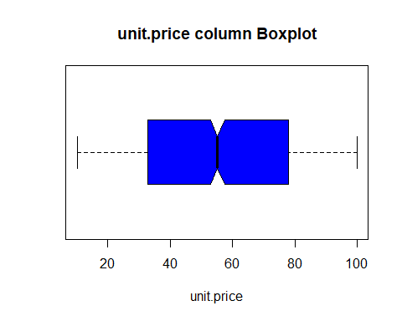

* There are no outliers in the “unit.price” column.

#### Boxplot for “Tax” column

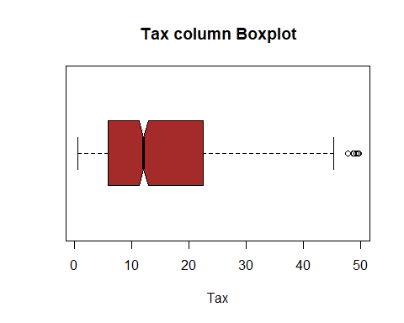

* There are outliers in the “Tax” column. I will keep them in my analysis because they represent true values in the data.

#### Boxplot for “Cogs” column

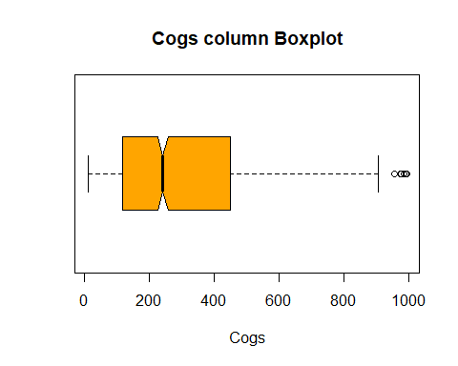

* There are outliers in the “Cogs” column. I will keep them in my analysis because they represent true values in the data.

#### Boxplot for “gross.margin.percentage” column

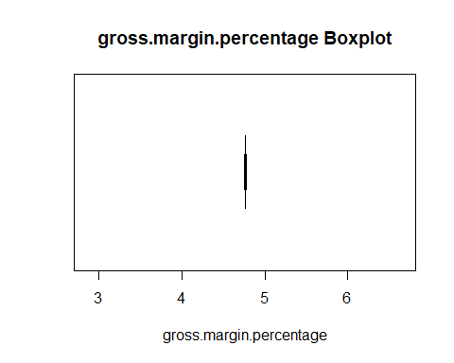

* There are no outliers in the “Tax” column.

#### Boxplot for “gross.income” column

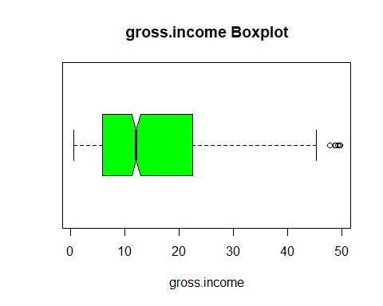

* There are outliers in the “gross.income” column. I will keep them in my analysis because they represent true values in the data.

#### Boxplot for “Rating” column

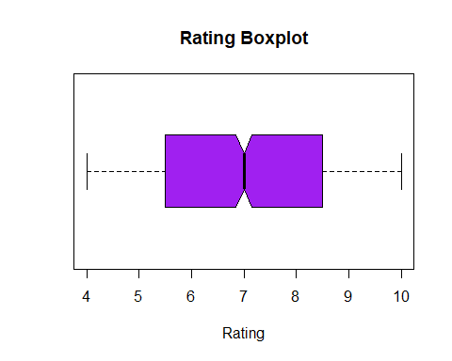

* There are no outliers in the “Rating” column.

#### Boxplot for “Total” column

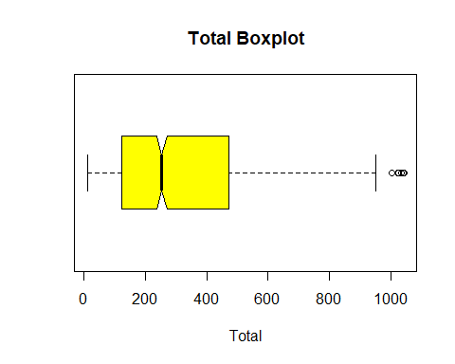

* There are outliers in the “Total” column. I will keep them in my analysis because they represent true values in the data.

# 4. Exploaratory Data Analysis.

## 4.1 Univariate Analysis.

### Distributions

#### Histograms:

plot_histogram(df)

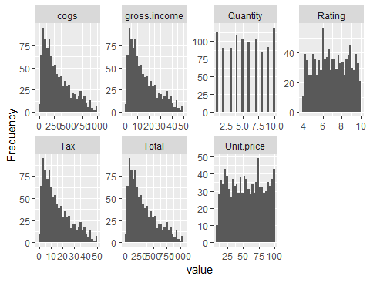

* From the histograms, we get the following insights:
  + Cogs, gross.income, Tax and Total columns are positively skewed, meaning we expect the mean will be greater than the median.
  + Unit.price and Rating columns have fairly even distribution.

#### Bar Plots:

plot_bar(df)

## 3 columns ignored with more than 50 categories.  
## Invoice.ID: 1000 categories  
## Date: 89 categories  
## Time: 506 categories

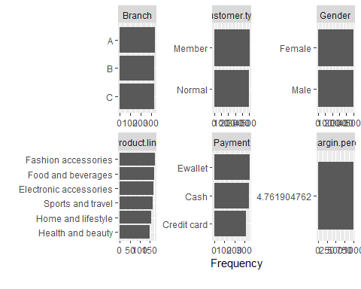

* From the bar plots, we observe that Branch, Customer.type, Gender, Product.line and Payment columns have an even distribution.

### Description and Summary of Data:

* Description:

describe(df)

## Warning in FUN(newX[, i], ...): no non-missing arguments to min; returning Inf

## Warning in FUN(newX[, i], ...): no non-missing arguments to max; returning -Inf

## vars n mean sd median trimmed mad min  
## Invoice.ID* 1 1000 500.50 288.82 500.50 500.50 370.65 1.00  
## Branch* 2 1000 1.99 0.82 2.00 1.99 1.48 1.00  
## Customer.type* 3 1000 1.50 0.50 1.00 1.50 0.00 1.00  
## Gender* 4 1000 1.50 0.50 1.00 1.50 0.00 1.00  
## Product.line* 5 1000 3.45 1.72 3.00 3.44 1.48 1.00  
## Unit.price 6 1000 55.67 26.49 55.23 55.62 33.37 10.08  
## Quantity 7 1000 5.51 2.92 5.00 5.51 2.97 1.00  
## Tax 8 1000 15.38 11.71 12.09 14.00 11.13 0.51  
## Date 9 1000 NaN NA NA NaN NA Inf  
## Time* 10 1000 252.18 147.07 249.00 252.49 190.51 1.00  
## Payment* 11 1000 2.00 0.83 2.00 2.00 1.48 1.00  
## cogs 12 1000 307.59 234.18 241.76 279.91 222.65 10.17  
## gross.margin.percentage 13 1000 4.76 0.00 4.76 4.76 0.00 4.76  
## gross.income 14 1000 15.38 11.71 12.09 14.00 11.13 0.51  
## Rating 15 1000 6.97 1.72 7.00 6.97 2.22 4.00  
## Total 16 1000 322.97 245.89 253.85 293.91 233.78 10.68  
## max range skew kurtosis se  
## Invoice.ID* 1000.00 999.00 0.00 -1.20 9.13  
## Branch* 3.00 2.00 0.02 -1.51 0.03  
## Customer.type* 2.00 1.00 0.00 -2.00 0.02  
## Gender* 2.00 1.00 0.00 -2.00 0.02  
## Product.line* 6.00 5.00 0.06 -1.28 0.05  
## Unit.price 99.96 89.88 0.01 -1.22 0.84  
## Quantity 10.00 9.00 0.01 -1.22 0.09  
## Tax 49.65 49.14 0.89 -0.09 0.37  
## Date -Inf -Inf NA NA NA  
## Time* 506.00 505.00 0.00 -1.25 4.65  
## Payment* 3.00 2.00 0.00 -1.55 0.03  
## cogs 993.00 982.83 0.89 -0.09 7.41  
## gross.margin.percentage 4.76 0.00 NaN NaN 0.00  
## gross.income 49.65 49.14 0.89 -0.09 0.37  
## Rating 10.00 6.00 0.01 -1.16 0.05  
## Total 1042.65 1031.97 0.89 -0.09 7.78

* Summary:

summary(df)

## Invoice.ID Branch Customer.type Gender   
## 101-17-6199: 1 A:340 Member:501 Female:501   
## 101-81-4070: 1 B:332 Normal:499 Male :499   
## 102-06-2002: 1 C:328   
## 102-77-2261: 1   
## 105-10-6182: 1   
## 105-31-1824: 1   
## (Other) :994   
## Product.line Unit.price Quantity Tax   
## Electronic accessories:170 Min. :10.08 Min. : 1.00 Min. : 0.5085   
## Fashion accessories :178 1st Qu.:32.88 1st Qu.: 3.00 1st Qu.: 5.9249   
## Food and beverages :174 Median :55.23 Median : 5.00 Median :12.0880   
## Health and beauty :152 Mean :55.67 Mean : 5.51 Mean :15.3794   
## Home and lifestyle :160 3rd Qu.:77.94 3rd Qu.: 8.00 3rd Qu.:22.4453   
## Sports and travel :166 Max. :99.96 Max. :10.00 Max. :49.6500   
##   
## Date Time Payment cogs   
## Min. :2020-01-01 Length:1000 Cash :344 Min. : 10.17   
## 1st Qu.:2020-01-24 Class :character Credit card:311 1st Qu.:118.50   
## Median :2020-02-13 Mode :character Ewallet :345 Median :241.76   
## Mean :2020-02-14 Mean :307.59   
## 3rd Qu.:2020-03-08 3rd Qu.:448.90   
## Max. :2020-03-30 Max. :993.00   
##   
## gross.margin.percentage gross.income Rating Total   
## Min. :4.762 Min. : 0.5085 Min. : 4.000 Min. : 10.68   
## 1st Qu.:4.762 1st Qu.: 5.9249 1st Qu.: 5.500 1st Qu.: 124.42   
## Median :4.762 Median :12.0880 Median : 7.000 Median : 253.85   
## Mean :4.762 Mean :15.3794 Mean : 6.973 Mean : 322.97   
## 3rd Qu.:4.762 3rd Qu.:22.4453 3rd Qu.: 8.500 3rd Qu.: 471.35   
## Max. :4.762 Max. :49.6500 Max. :10.000 Max. :1042.65   
##

### A function to get the mode

# a function for code  
mode <- function(x){  
 uniqx <- unique(x)  
 uniqx[which.max(tabulate(match(x, uniqx)))]  
}

#### Unit.price Column

* From the summary and description, we can gather the following about the Unit.price column:
  + Mean: 55.67
  + Median: 55.23
  + Skewness: 0.01
  + Kurtosis: -1.22
* The mode is:

mode(df$Unit.price)

## [1] 83.77

#### Quantity Column

* From the summary and description, we can gather the following about the Quantity column:
  + Mean: 5.51
  + Median: 5.00
  + Skewness: 0.01
  + Kurtosis: -1.22
* The mode is:

mode(df$Quantity)

## [1] 10

#### Tax Column

* From the summary and description, we can gather the following about the Tax column:
  + Mean: 15.3794
  + Median: 12.0880
  + Skewness: 0.89
  + Kurtosis: -0.09
* The mode is:

mode(df$Tax)

## [1] 39.48

#### Cogs column

* From the summary and description, we can gather the following about the Cogs column:
  + Mean: 307.59
  + Median: 241.76
  + Skewness: 0.89
  + Kurtosis: -0.09
* The mode is:

mode(df$cogs)

## [1] 789.6

#### gross.income column

* From the summary and description, we can gather the following about the gross.income column:
  + Mean: 15.3794
  + Median: 12.0880
  + Skewness: 0.89
  + Kurtosis: -0.09
* The mode is:

mode(df$gross.income)

## [1] 39.48

#### Rating column

* From the summary and description, we can gather the following about the Rating column:
  + Mean: 6.973
  + Median: 7.000
  + Skewness: 0.01
  + Kurtosis: -1.16
* The mode is:

mode(df$Rating)

## [1] 6

#### Total column

* From the summary and description, we can gather the following about the Total column:
  + Mean: 322.97
  + Median: 253.85
  + Skewness: 0.89
  + Kurtosis: -0.09
* The mode is:

mode(df$Total)

## [1] 829.08

## 4.2 Bivariate Analysis

ggplot(df, aes(x=Product.line, y=Total)) +  
 geom_point()

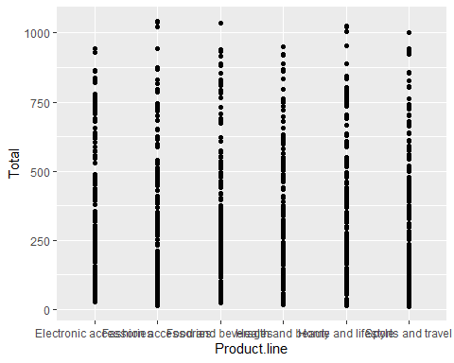

* Fashion Accessories have the highest Total prices while health and beauty products have lower prices.

ggplot(df ,aes(Gender, Total)) +  
 geom_point()

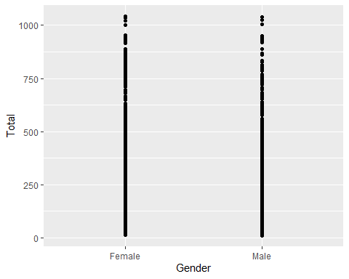

* Total Price is equally distributed in terms of gender

ggplot(df, aes(Payment, Total)) +  
 geom_point()

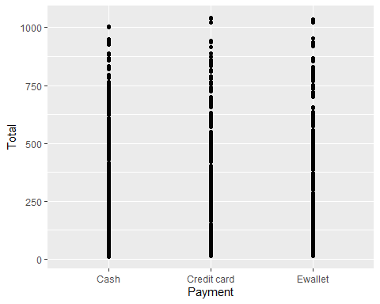

* The payment methods are nearly identical for the total prices of items at checkouts, with Credit card payments being used for more expensive transactions.

ggplot(df, aes(gross.income, Total)) +  
 geom_point()

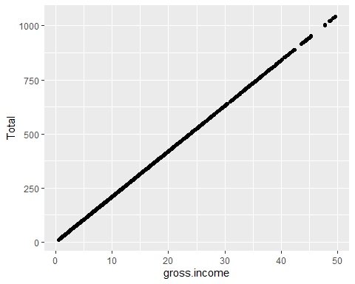

* There is a positive linear relationship between the total at checkout and the consumers gross income.

ggplot(df, aes(Customer.type , Total)) +  
 geom_point()

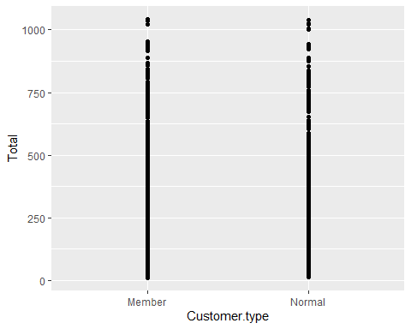

* Members and non members have a nearly equal distribution in expenditure with Members having no breaks in prices.

ggplot(df, aes(Tax, Total)) +  
 geom_point()

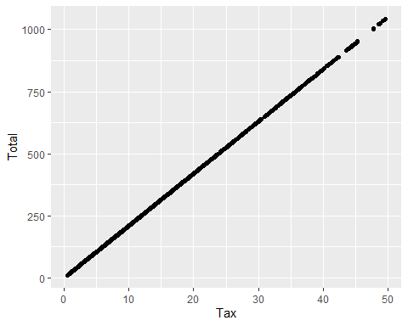

* There is a positive linear relationship between tax and total price. As expected, the higher the tax on items, the more they cost.

ggplot(df, aes(Unit.price, Total)) +  
 geom_point()

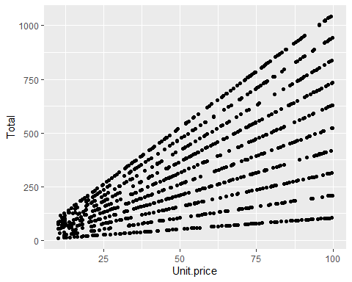

* There are several positive linear relationships with the Unit Price variable: the higher it is the higher the total price is.

### Heatmap

# Heat map  
# Checking the relationship between the variables  
  
  
# Using Numeric variables only  
numeric_tbl <- df %>%  
 select_if(is.numeric) %>%  
 select(Unit.price, Tax, cogs, gross.income, Rating, Total)  
  
# Calculate the correlations  
corr <- cor(numeric_tbl, use = "complete.obs")  
ggcorrplot(round(corr, 2),  
 type = "full", lab = T)

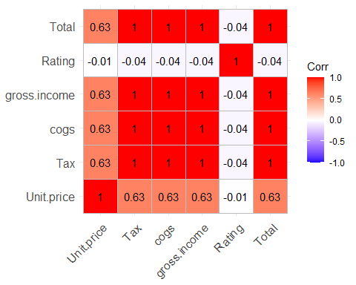

* The following variables show strong correlation:
  + Unit Price with Tax, cogs, gross.income and Total.Strong correlation of 0.63.
  + Tax with cogs, gross.income and Total. Very strong correlation of 1.
  + gross.income to Unit.price, Tax, cogs and Total. Very strong correlation of 1.

# 5. Part 1: Dimensionality Reduction

* This section of the project entails reducing the dataset to a low dimensional dataset using the t-SNE algorithm or PCA. I will perform analysis and provide insights gained.

# Label Encoding branch column and storing in a copy  
branch <- LabelEncoder.fit(df$Branch)  
df$Branch <- transform(branch, factor(df$Branch))  
  
# Label Encoding Gender column and storing in a copy  
gender <- LabelEncoder.fit(df$Gender)  
df$Gender <- transform(gender, factor(df$Gender))  
  
# Label Encoding Customer.type column and storing in a copy  
customer <- LabelEncoder.fit(df$Customer.type)  
df$Customer.type <- transform(customer, factor(df$Customer.type))  
  
# Label Encoding product.line column and storing in a copy  
product <- LabelEncoder.fit(df$Product.line)  
df$Product.line <- transform(product, factor(df$Product.line))  
  
# Label Encoding payment column and storing in a copy  
pay <- LabelEncoder.fit(df$Payment)  
df$Payment <- transform(pay, factor(df$Payment))

# for plotting  
  
colors = rainbow(length(unique(df$Total)))  
names(colors) = unique(df$Total)

# Executing the algorithm on curated data  
model <- Rtsne(df, dims=2, perplexity=30, verbose= TRUE, max_iter=500)

## Performing PCA  
## Read the 1000 x 50 data matrix successfully!  
## OpenMP is working. 1 threads.  
## Using no_dims = 2, perplexity = 30.000000, and theta = 0.500000  
## Computing input similarities...  
## Building tree...  
## Done in 0.22 seconds (sparsity = 0.103032)!  
## Learning embedding...  
## Iteration 50: error is 61.908953 (50 iterations in 0.21 seconds)  
## Iteration 100: error is 55.231591 (50 iterations in 0.16 seconds)  
## Iteration 150: error is 54.293801 (50 iterations in 0.19 seconds)  
## Iteration 200: error is 53.905867 (50 iterations in 0.18 seconds)  
## Iteration 250: error is 53.631579 (50 iterations in 0.18 seconds)  
## Iteration 300: error is 0.727163 (50 iterations in 0.16 seconds)  
## Iteration 350: error is 0.560715 (50 iterations in 0.14 seconds)  
## Iteration 400: error is 0.515843 (50 iterations in 0.14 seconds)  
## Iteration 450: error is 0.500396 (50 iterations in 0.15 seconds)  
## Iteration 500: error is 0.492476 (50 iterations in 0.13 seconds)  
## Fitting performed in 1.64 seconds.

# getting the duration of the execution  
  
exeTimeTsne <- system.time(Rtsne(df, dims = 2, perplexity=30, verbose=TRUE, max_iter = 500))

## Performing PCA  
## Read the 1000 x 50 data matrix successfully!  
## OpenMP is working. 1 threads.  
## Using no_dims = 2, perplexity = 30.000000, and theta = 0.500000  
## Computing input similarities...  
## Building tree...  
## Done in 0.22 seconds (sparsity = 0.103032)!  
## Learning embedding...  
## Iteration 50: error is 61.371402 (50 iterations in 0.22 seconds)  
## Iteration 100: error is 54.437223 (50 iterations in 0.14 seconds)  
## Iteration 150: error is 53.522988 (50 iterations in 0.14 seconds)  
## Iteration 200: error is 53.307307 (50 iterations in 0.14 seconds)  
## Iteration 250: error is 53.222941 (50 iterations in 0.13 seconds)  
## Iteration 300: error is 0.738740 (50 iterations in 0.13 seconds)  
## Iteration 350: error is 0.562078 (50 iterations in 0.13 seconds)  
## Iteration 400: error is 0.524945 (50 iterations in 0.12 seconds)  
## Iteration 450: error is 0.509525 (50 iterations in 0.13 seconds)  
## Iteration 500: error is 0.496567 (50 iterations in 0.13 seconds)  
## Fitting performed in 1.42 seconds.

summary(model)

## Length Class Mode   
## N 1 -none- numeric  
## Y 2000 -none- numeric  
## costs 1000 -none- numeric  
## itercosts 10 -none- numeric  
## origD 1 -none- numeric  
## perplexity 1 -none- numeric  
## theta 1 -none- numeric  
## max_iter 1 -none- numeric  
## stop_lying_iter 1 -none- numeric  
## mom_switch_iter 1 -none- numeric  
## momentum 1 -none- numeric  
## final_momentum 1 -none- numeric  
## eta 1 -none- numeric  
## exaggeration_factor 1 -none- numeric

head(model$Y)

## [,1] [,2]  
## [1,] 17.002746 7.769618  
## [2,] 6.398792 -15.646250  
## [3,] -7.575234 13.573013  
## [4,] 10.791580 3.631091  
## [5,] 15.975237 15.943053  
## [6,] 18.060238 15.608866

plot(model$Y, t='n', main="Output of TSNE")  
text(model$Y, labels=df$Total, col=colors[df$Total] )

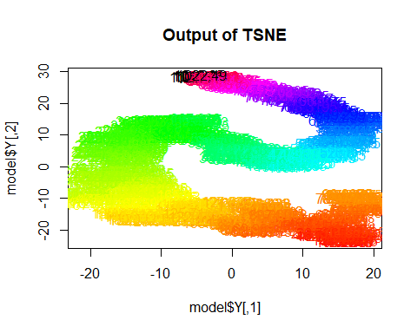

# 6. Part 2: Feature Selection

## 6.1 Filter Methods

# Using Numeric variables only  
numeric_table <- df %>%  
 select_if(is.numeric) %>%  
 select(Unit.price, Tax, cogs, gross.income, Rating, Total)

corrMat <- cor(numeric_table)  
  
# highly correlated features  
high <- findCorrelation(corrMat, cutoff = 0.75)  
  
# names of highly correlated features  
names(numeric_table[, high])

## [1] "Tax" "cogs" "gross.income"

# Removing Tax, cogs and gross.income  
numeric_table2 <- df %>%  
 select_if(is.numeric) %>%  
 select(Unit.price, Rating, Total)

# data set without highly correlated variables  
c2 <- numeric_table[-high]  
  
# plotting  
par(mfrow = c(1, 2))  
  
corrplot(corrMat, order = "hclust")  
corrplot(cor(c2), order = "hclust")

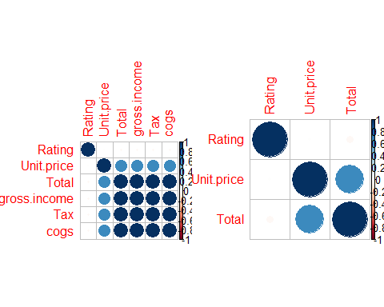

## 6.2 Feature Ranking

# From the FSelector package, we use the correlation coefficient as a unit of valuation.   
# This would be one of the several algorithms contained   
# in the FSelector package that can be used rank the variables.  
# ---  
#   
Scores <- linear.correlation(Total~.,numeric_table)  
Scores

## attr_importance  
## Unit.price 0.6339621  
## Tax 1.0000000  
## cogs 1.0000000  
## gross.income 1.0000000  
## Rating 0.0364417

# From the output above, we observe a list containing   
# rows of variables on the left and score on the right.   
# In order to make a decision, we define a cutoff   
# i.e. suppose we want to use the top 5 representative variables,   
# through the use of the cutoff.k function included in the FSelector package.   
# Alternatively, we could define our cutoff visually   
# but in cases where there are few variables than in high dimensional datasets.  
#   
# cutoff.k: The algorithms select a subset from a ranked attributes.   
# ---  
#  
Subset <- cutoff.k(Scores, 4)  
as.data.frame(Subset)

## Subset  
## 1 Tax  
## 2 cogs  
## 3 gross.income  
## 4 Unit.price

# We could also set cutoff as a percentage which would indicate   
# that we would want to work with the percentage of the best variables.  
# ---  
#  
Subset2 <-cutoff.k.percent(Scores, 0.4)  
as.data.frame(Subset2)

## Subset2  
## 1 Tax  
## 2 cogs

# Instead of using the scores for the correlation coefficient,   
# we can use an entropy - based approach as shown below;  
# ---  
#   
Scores2 <- information.gain(Total~., numeric_table)  
  
# Choosing Variables by cutoffSubset <- cutoff.k(Scores2, 5)  
# ---  
#   
Subset3 <- cutoff.k(Scores2, 5)  
as.data.frame(Subset3)

## Subset3  
## 1 Tax  
## 2 cogs  
## 3 gross.income  
## 4 Unit.price  
## 5 Rating

# 7. Conclusion

* Using Feature Ranking method with information gain of all variables being used as a metric of comparison, the Branch, Customer Type, Gender, Product Line and Unit Price columns would be the best to use for modeling a regressor with respect to Rating.